Predictive Modeling – WGU D208

NBM2 – NBM2 TASK 2: LOGISTIC REGRESSION FOR PREDICTIVE MODELING

Nadeem Ahmed

April 2022

**Part I: Research Question**

A: Describe the purpose of this data analysis by doing the following:

1. Summarize **one** research question that is relevant to a real-world organizational situation captured in the data set you have selected and that you will answer using logistic regression.

Can the probability of customer churning be predicted based on a set of regressed predictor values?

1. Define the objectives or goals of the data analysis. Ensure that your objectives or goals are reasonable within the scope of the data dictionary and are represented in the available data.

The objective in this analysis is to determine a minimum set of predictor variables that can help in predicting customer churn using logistic regression. This needs to be done with a high degree of accuracy so that the business can understanding what is causing customers to churn. This analysis will be able to determine which customers are at high risk of churn.

**Part II: Method Justification**

B: Describe logistic regression methods by doing the following:

1. Summarize the assumptions of a logistic regression model.

Here are the assumptions that must be met for a logistic regression model to be valid.

* There is little or no multicollinearity (high correlation) among predictor variables
* Binary regression requires the dependent variable to be binary.
* Variability needs to be reduced to only the meaningful variables.
* Predicts the probability of an outcome instead of the outcome itself.
* Large sample size is necessary.
* Binomial distribution rather than Gaussian distribution (churn vs not churn).
* Logarithm of odds of achieving 1. Independent variables are linearly related to the logit (log odds).

1. Describe the benefits of using the tool(s) you have chosen (i.e., Python, R, or both) in support of various phases of the analysis.

This analysis is done using Python, Jupyter Notebook, and VSCode. The benefit of Python is the abundance of statistical and modeling packages available including pandas, scikit, seaborn, numpy, etc. They are easy to configure, and Python is a simple, yet multi-faceted programming language which can accomplish much with a few lines of code. It is fast in comparison to R, as well. Throughout the analysis, we will be conducting data cleanup, data wrangling, and data analysis. Python helps achieve these techniques and Jupyter Notebook will provide a clean and readable output which will exemplify the analysis. Python has a package called ‘sklearn’ which will assist heavily in the logistic regression analysis.

1. Explain why logistic regression is an appropriate technique to analyze the research question summarized in Part I.

Logistic regression is an appropriate technique because the dependent variable we are investigating is binomial; churn can either be a yes or no, therefore it is binary. The purpose of the research question is understood: which customers are at risk of churn based on the services and other variables in the dataset. This will be done by removing predictor variables (age, income, gender, techie, etc.) in a regression analysis and seeing correlation that has on the degree of accuracy, fit, and relationship to the target variable, churn.

**Part III: Data Preparation**

C: Summarize the data preparation process for multiple regression analysis by doing the following:

1. Describe your data preparation goals and the data manipulations that will be used to achieve the goals.

I will begin by importing the necessary rudimentary packages like pandas, seaborn, matplotlib, numpy, and sklearn. I know that I will be using these packages for this preparation, manipulation, and analysis. Next, we’ll move to reading the data into Python via the pandas package using the read_csv command.

Once the data is available in Python, we will do an initial investigation of the data structure using .info() and .describe(). Then we can examine the variable names and address any grammatical errors, improper naming conventions, potential missing data and outliers.

We can replace missing values with meaningful inputs and remove outliers, if necessary. We know that the target variable is MonthlyCharge. We can also make an educated guess on the predictor variables; rather what the predictor variables will not be. We will use the ‘drop()’ function to remove data that is not of value to this analysis.

We will consider the continuous predictor variables and the categorical predictor variables, as well. The categorical predictor variables will need to be converted to continuous types. We’ll do this by using ‘.get_dummies()’ which will create new numerical variables. We’ll use histograms and other visual plots to assess the relationships and correlations between the corresponding variables.

Lastly, the customer surveys can be used in the analysis to help make sense of what services are delivering value to the company and how the survey may help in predicting customer churn.

1. Discuss the summary statistics, including the target variable and *all* predictor variables that you will need to gather from the data set to answer the research question.

After running a few simple commands like info() and describe() we see that the dataset contains 50 columns and 10,000 records. The target variable is Churn. There are a few columns that can be removed from the dataset because they will not contribute to the correlation to monthly charge. This includes 'CaseOrder', 'Customer_id', 'Interaction', 'UID', 'County', 'Lat', 'Lng', 'Population', 'Area', 'TimeZone', ‘Marital’, ‘PaymentMethod’ ‘City’, ‘State’, ‘Zip’, and 'Job'. That leaves 34 columns with 10,000 rows. Out of those 34, one is Churn, so there are a possible 33 predictor variables for our target variable. All the categorical binomial variables were converted from Yes and No to 1 and 0, respectively.

1. Explain the steps used to prepare the data for the analysis, including the annotated code.

* Import the necessary Python Packages.

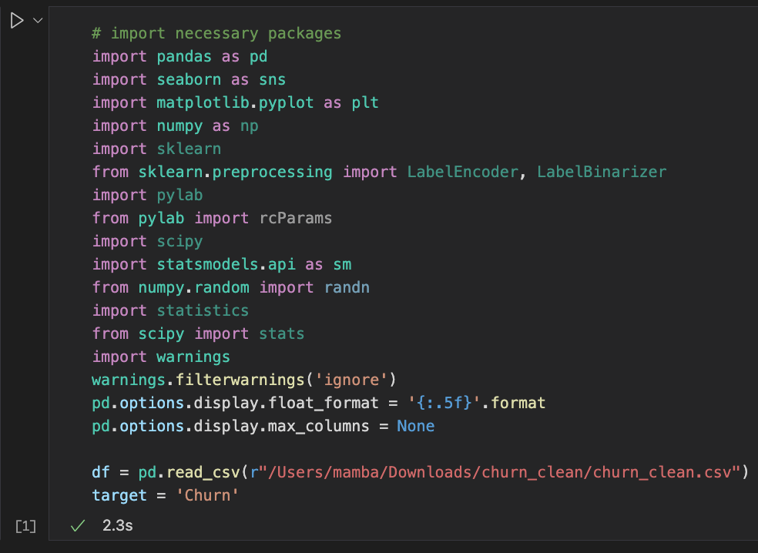

* Understand the raw dataframe

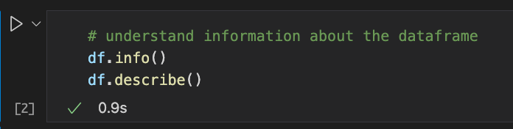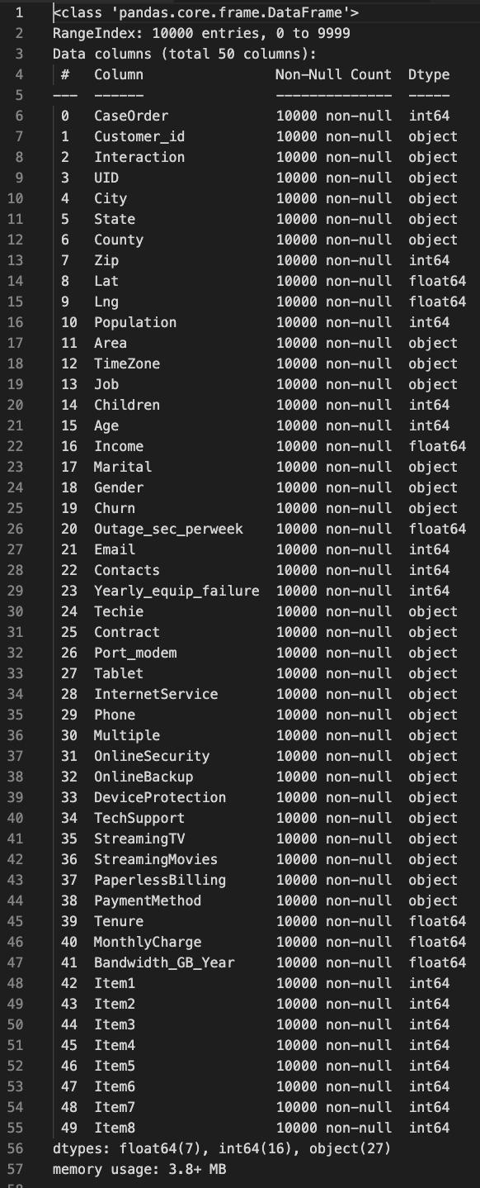

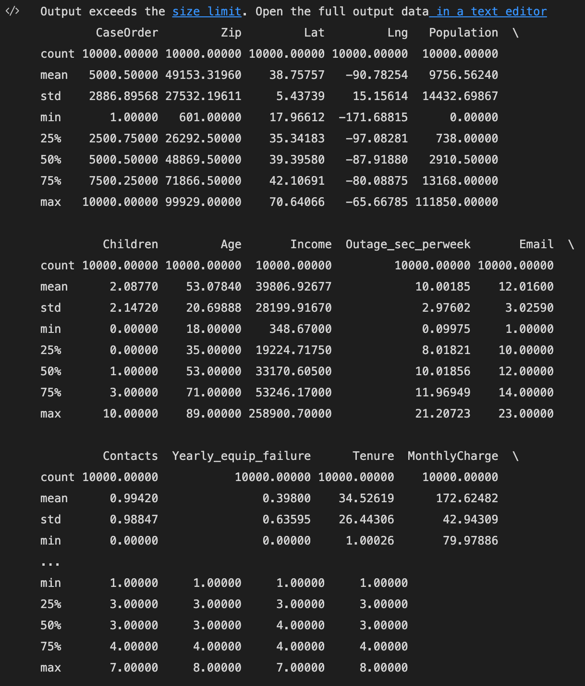

* Rename any columns that could assist with understanding the dataframe

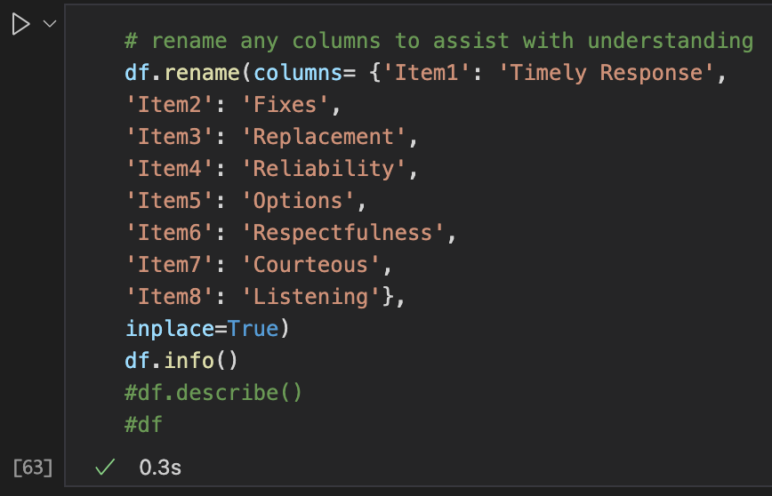

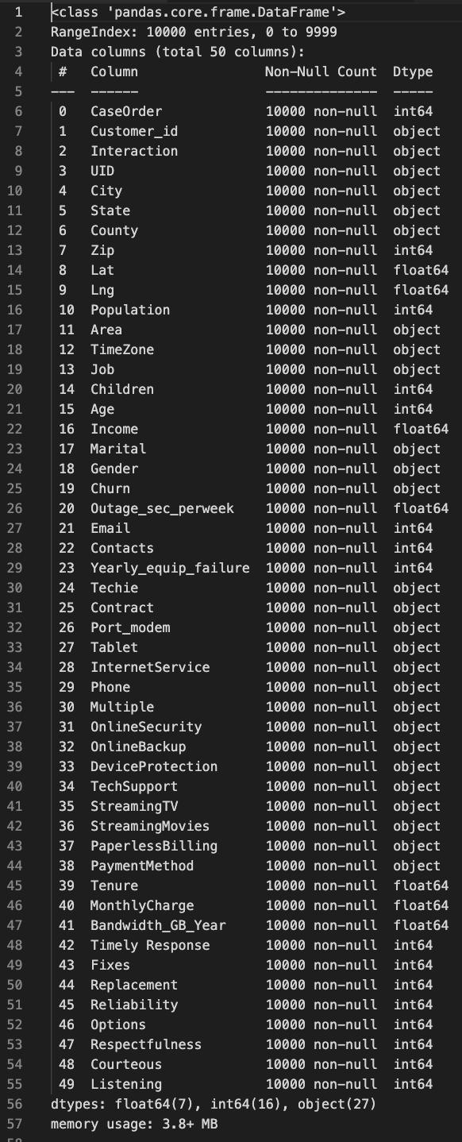

* Create a different dataframe for the columns

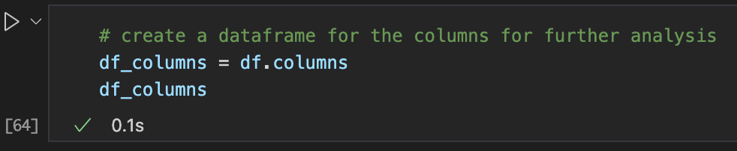

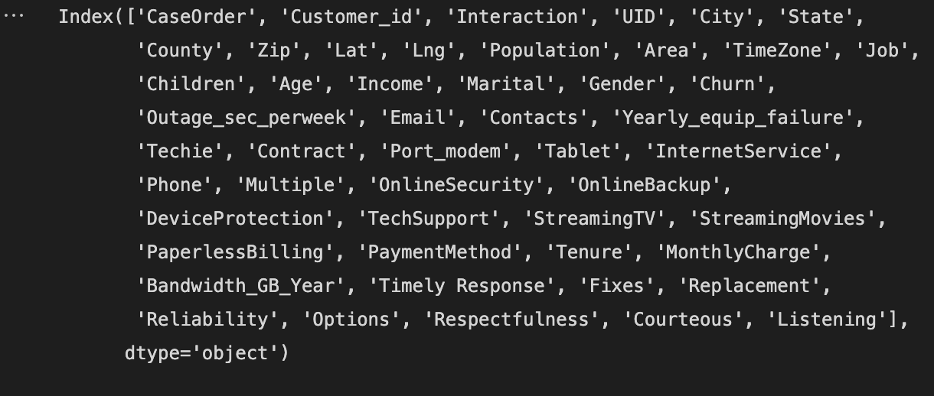

* Remove any variables that will not assist in the correlation analysis to the target variable. Here we got rid of the customer detail data that did not pertain to churn and survey statistics.

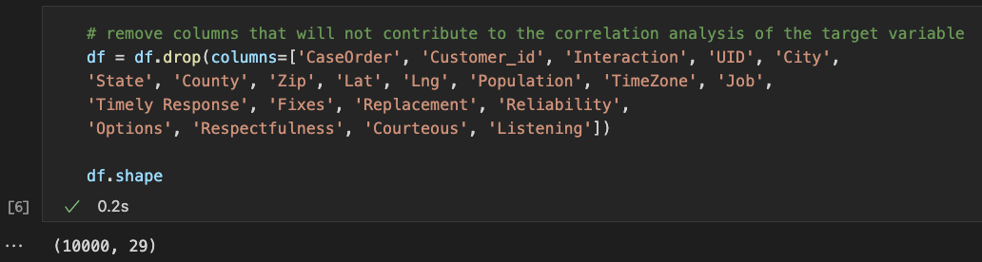

* Explore the dataset for any missing data, null values, and duplicates. We will also look for outliers after this.

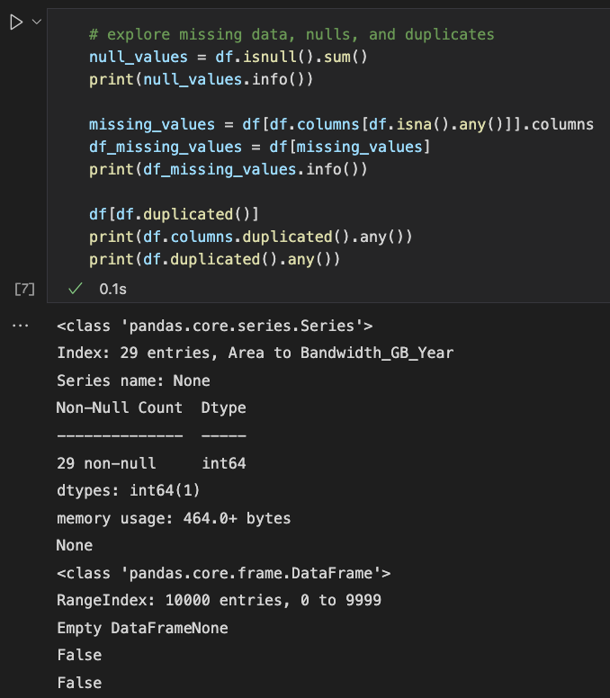

The data set shows no missing, null, or duplicate values. This is a clean dataset which is ready for analysis.

* We then look at the dataset to determine how many numerical variables there are vs how many categorical variables there are.

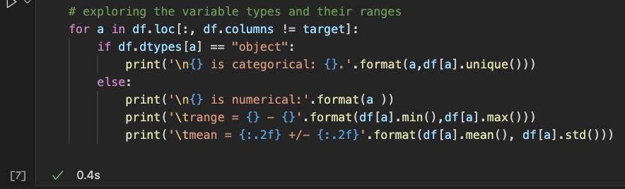

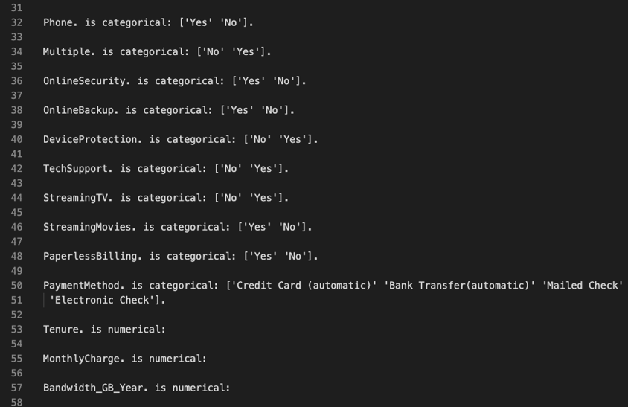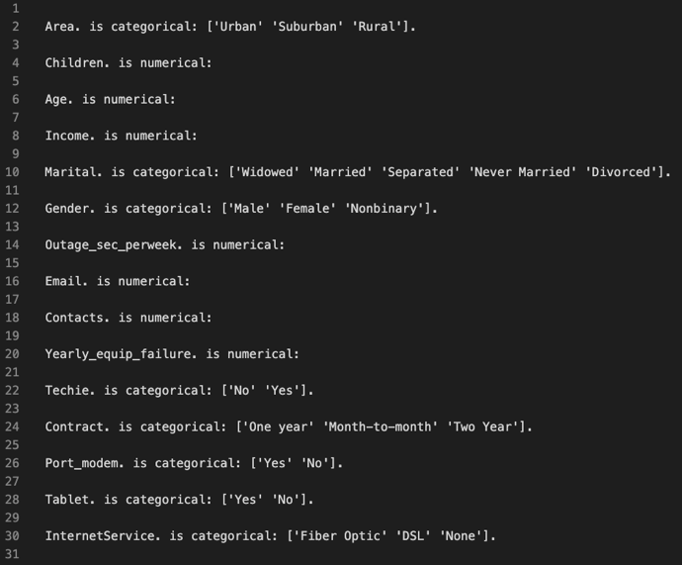

We see that we have 10 numerical variables and 18 categorical variables, outside of the target variable, ‘Churn’.

We can examine Churn to gain familiarity.

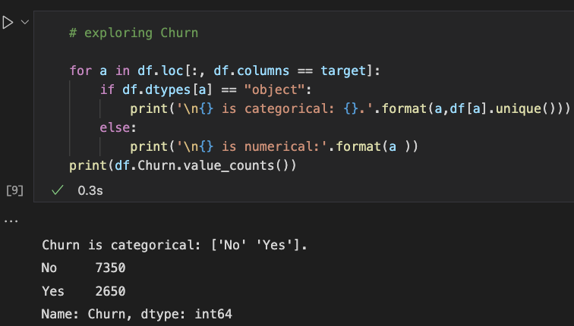

There are 26.5% customers who have churned.

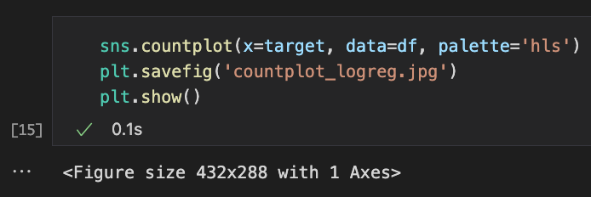

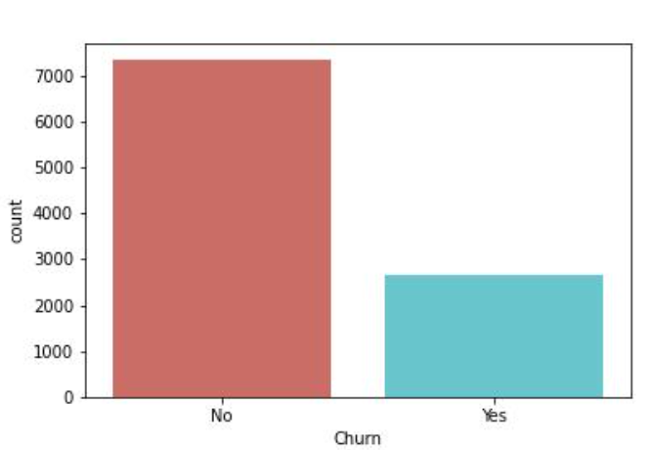

The countplot shows the distribution of Churn, our target variable.

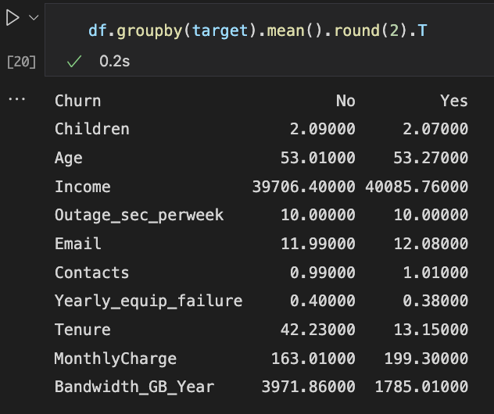

We examine the mean of numerical variables against Churn. There are 3 variables with a high degree of difference: Tenure, MonthlyCharges, and Bandwidth_GB_Year. Tenure is 42 [months] for existing customer and 13 [months] for churned customers. MonthlyCharges is $163 for existing customers and $199 for churned customers. Bandwidth_GB_Year is 3,972 GB for existing customers and 1,785 GB for churned customers.

1. Generate univariate and bivariate visualization of the distributions of variables in the cleaned data set. Include the target variable in your bivariate visualizations.

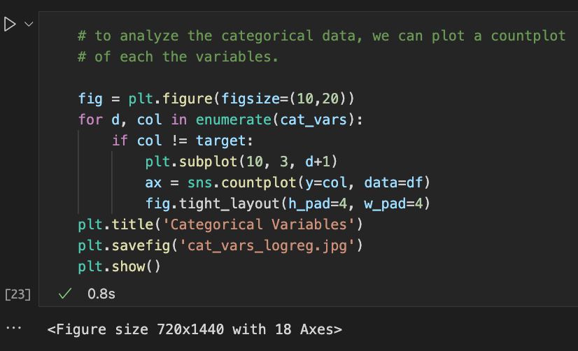

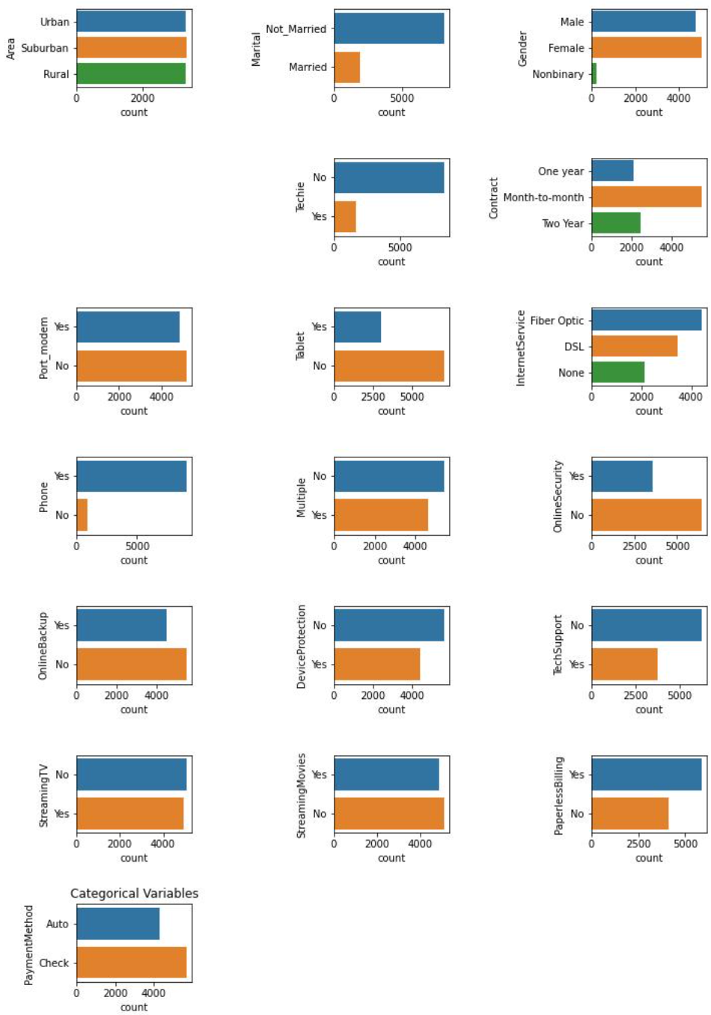

This univariate visualization gives us an insight to the distribution of the categorical predictor variables. We see that most of the customers are not married, very few identify as nonbinary, most do not identify as techies, very few have not purchased phone service, and most are enrolled in a month-to-month contract.

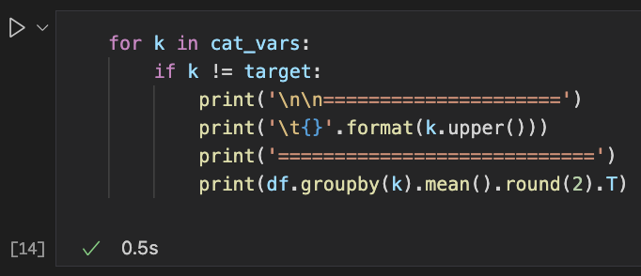

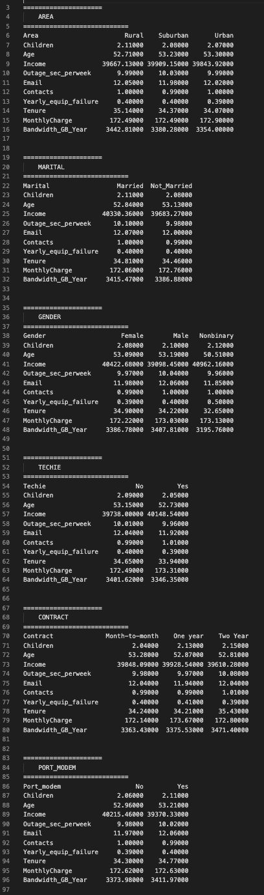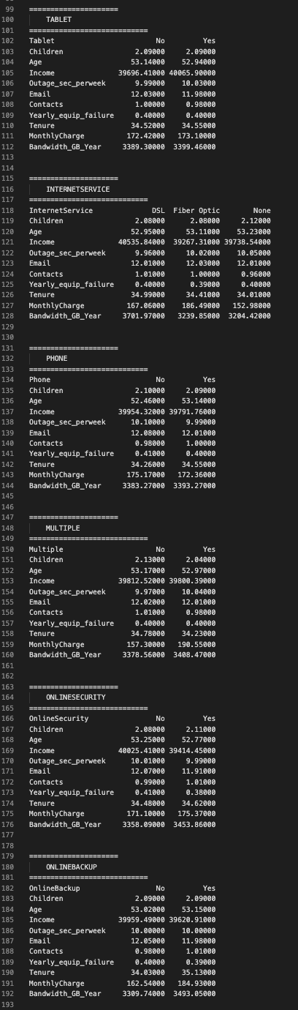

This bivariate analysis focuses on the mean values of the numerical predictor variables against the categorical predictor variables. It shows that customers who purchased fiber optic pay on average $186 vs those who purchased DSL pay on average $167. Customers who have multiple phone lines pay $33 more than those who don’t have multiple lines. Those who purchased online backup pay about $22 more than those who didn’t purchase online backup. Those who purchased device protection pay $14 more than those who didn’t purchase device protection. Customers who purchased tech support pay $10 vs those who don’t have tech support. Customers who purchased tv streaming pay $42 more than those who don’t have tv streaming and those who have movie streaming pay $52 more than those who don’t have movie streaming.

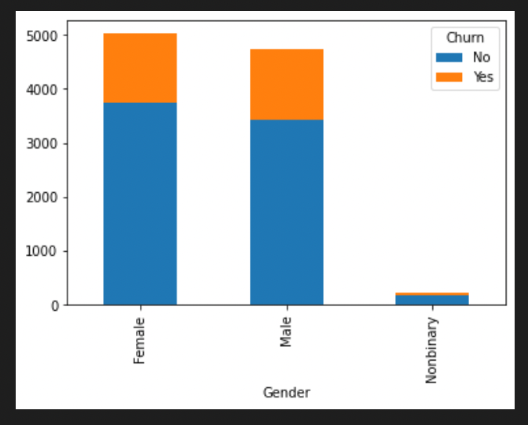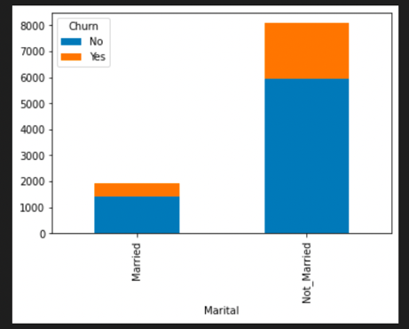We can run a stacked plot visualization showing the categorical predictor variables distributed by the target variable.

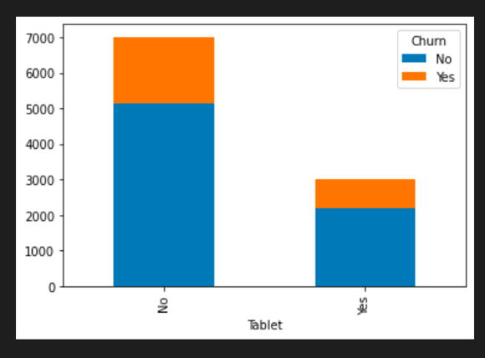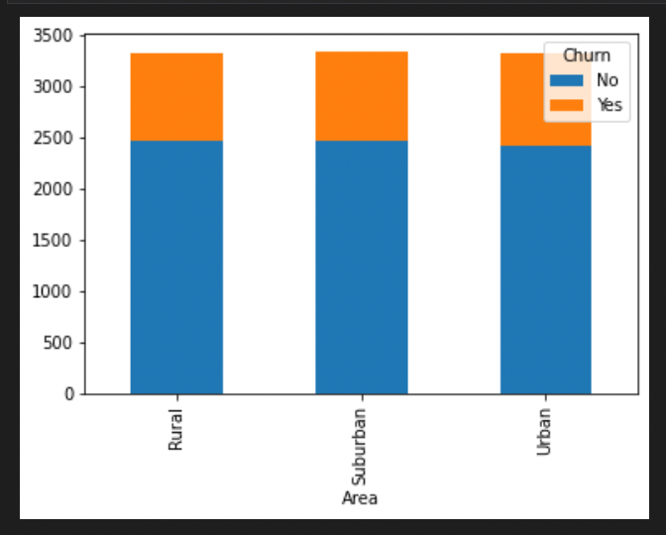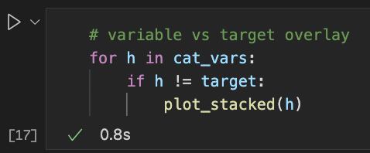

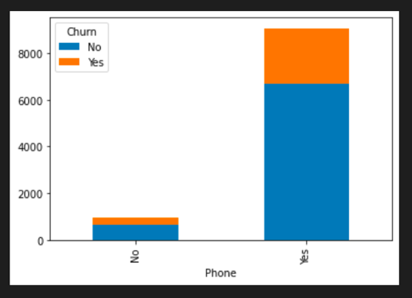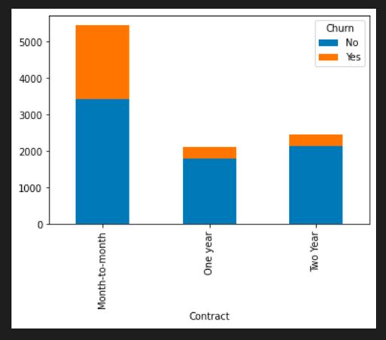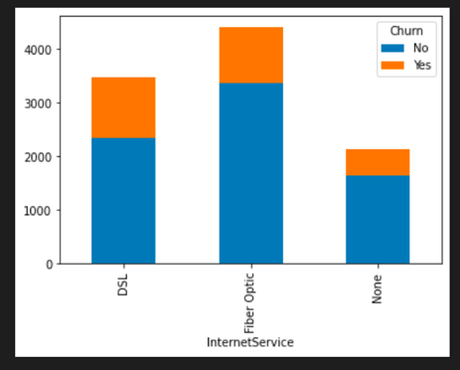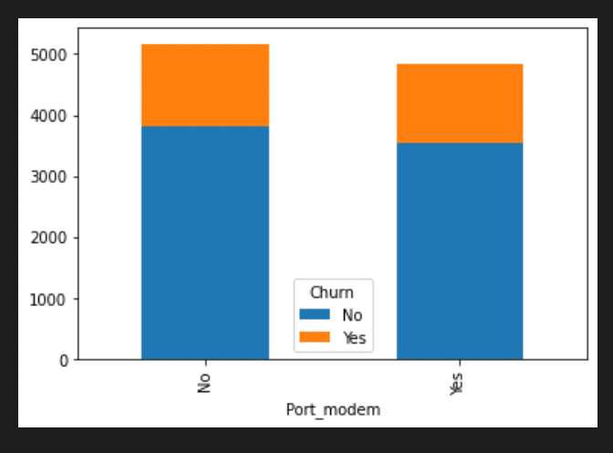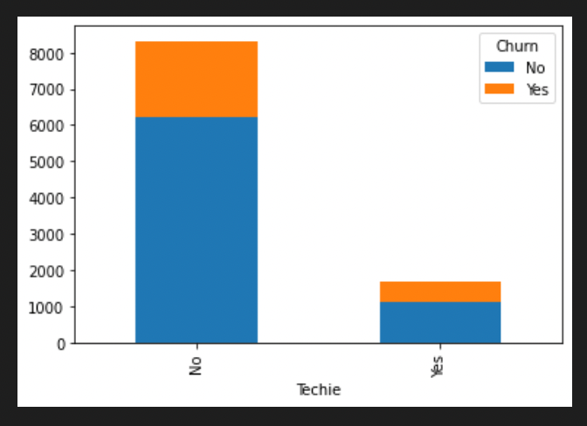

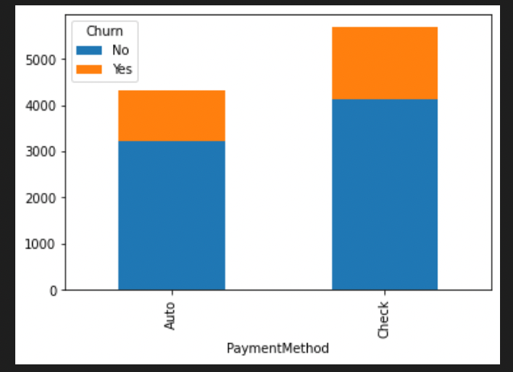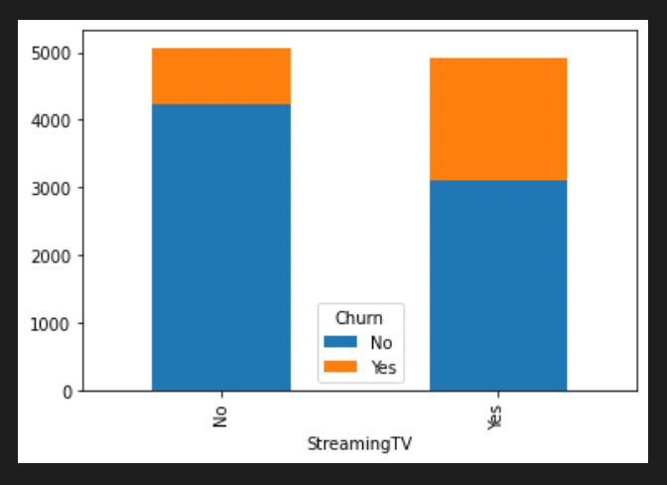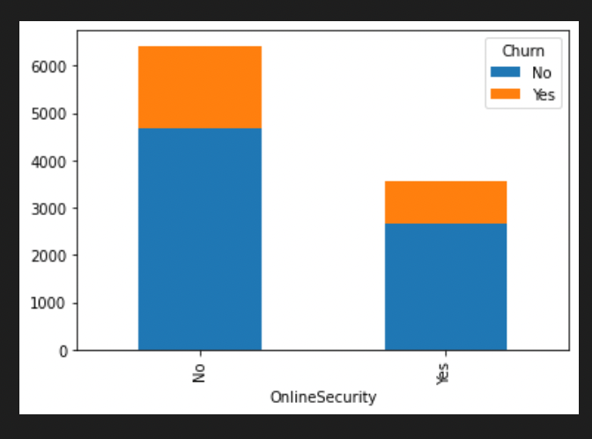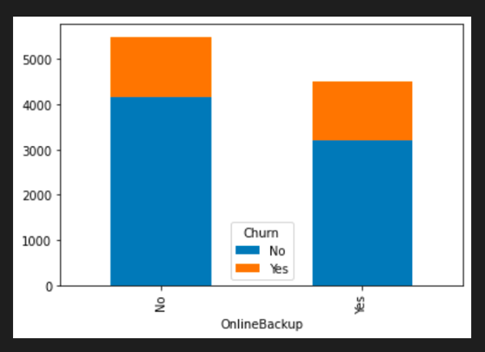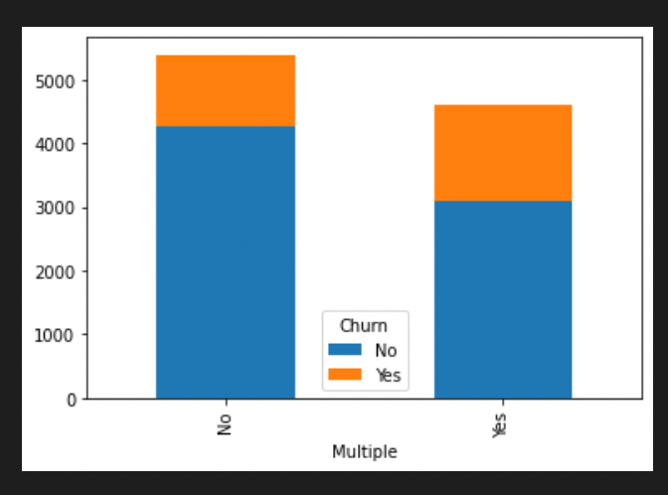

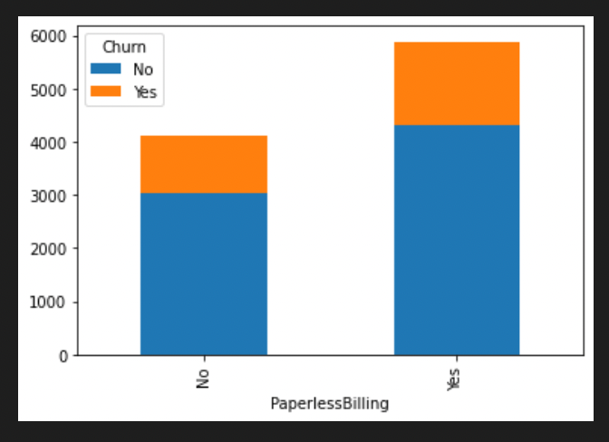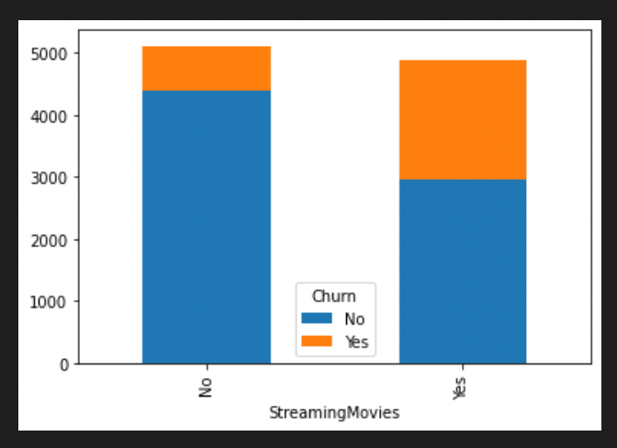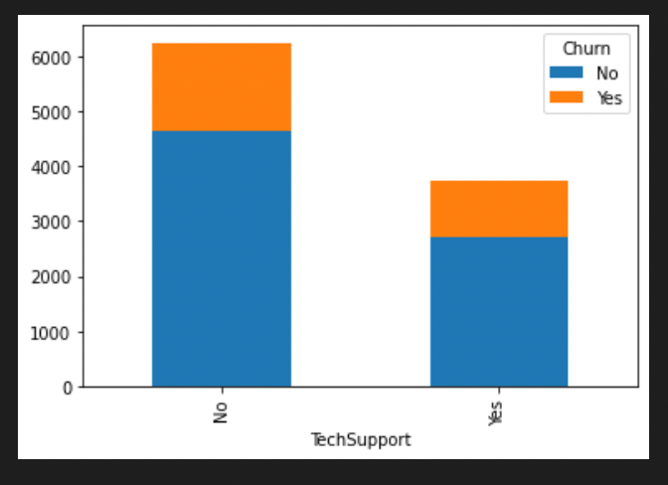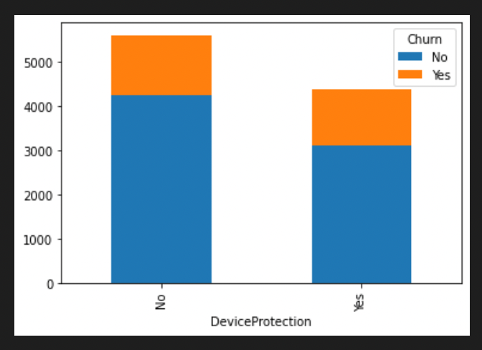

Now that an analysis has been done on the existing dataset, it affirms the value of a few predictor variables in our future logistic regression analysis and visualization. This analysis showed that huge disparity in values for some of the categorical variables which make them good options for predictors. These include Marital, Techie, Contract, Tablet, InternetService, OnlineSecurity, OnlineBackup, DeviceProtection, StreamingTV, StreamingMovies, PaperlessBilling, and PaymentMethod.

Next step is to convert the categorical predictor variables to dummy numerical variables. We use the getdummies() pandas function to create dummy variables as numerical types if the variable was in the cat_vars dataframe.

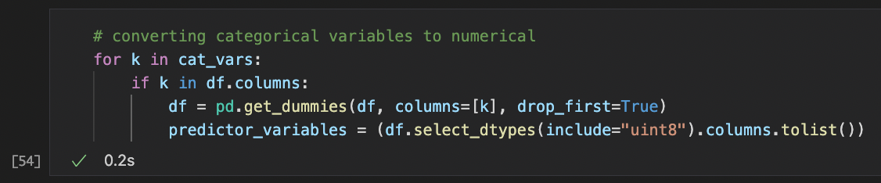

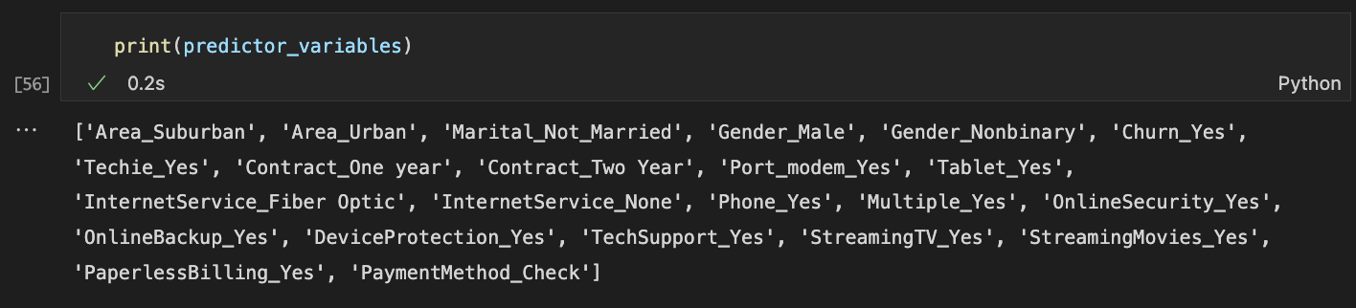

The next step is to analyze the numeric predictor variables.

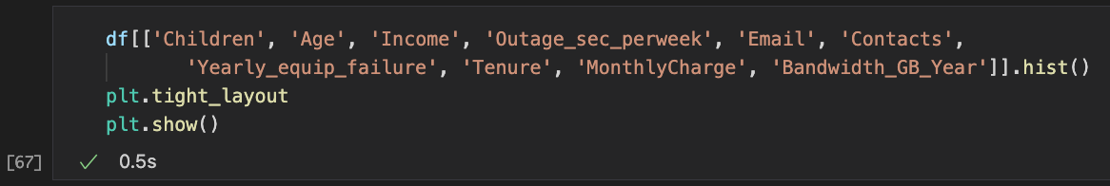

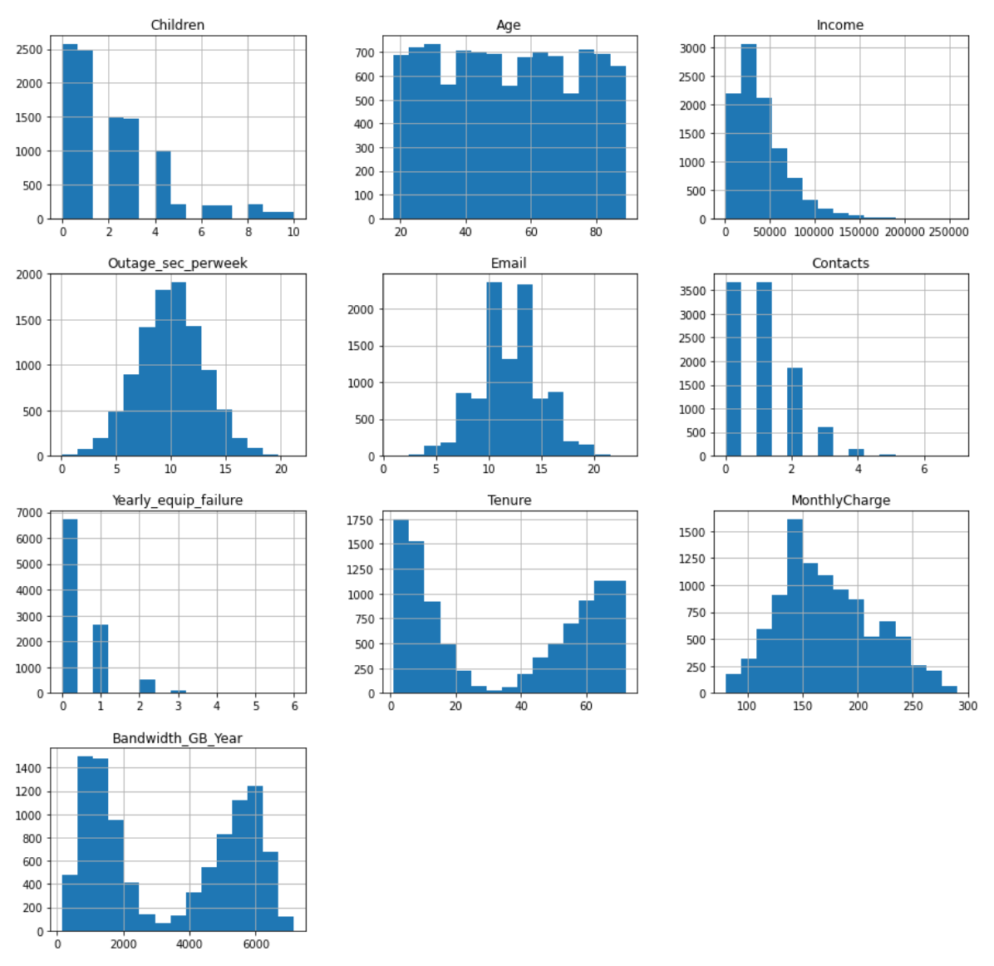

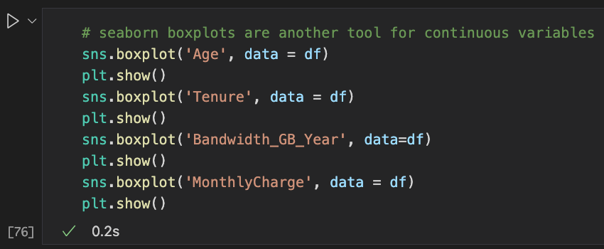

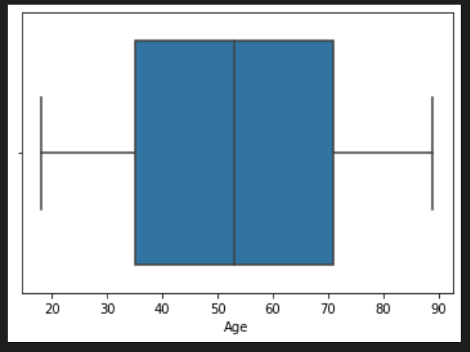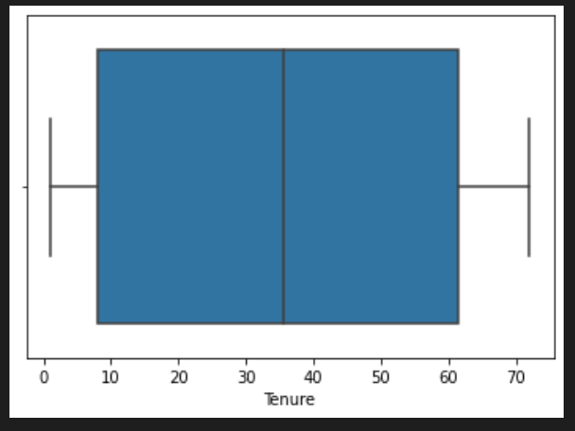

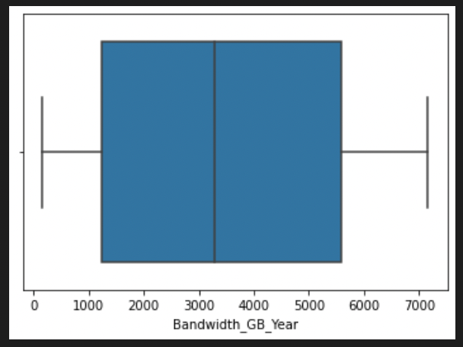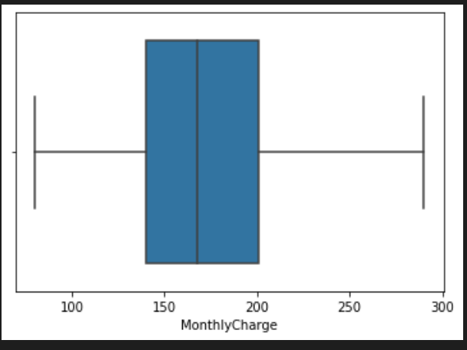

For the following analysis we look at the existing dataframe to make sure we have everything we need.

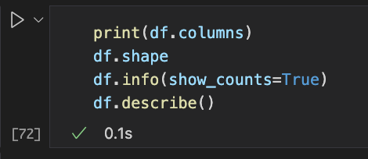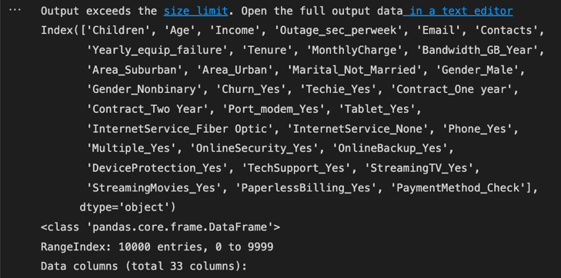

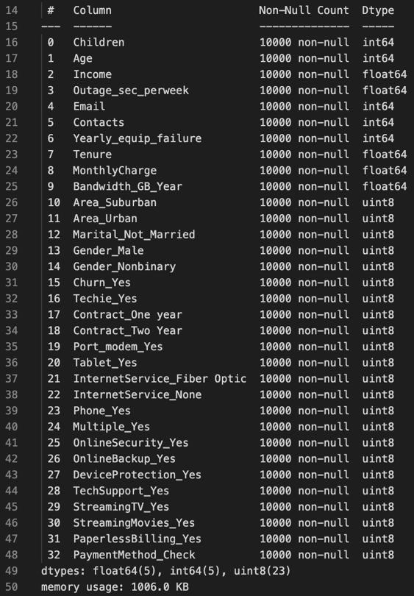

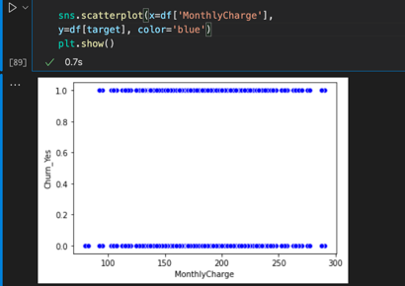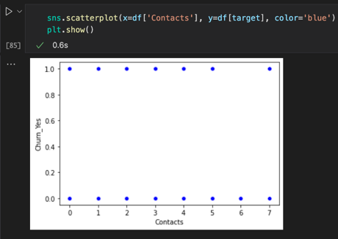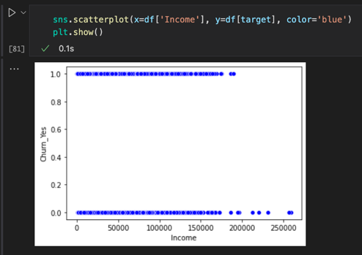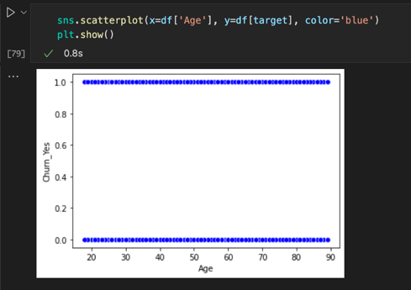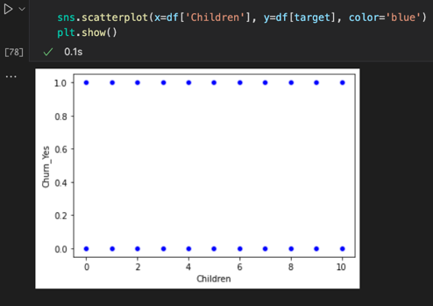We can run a seaborn scatterplot of the numerical predictor variables against churn (target).

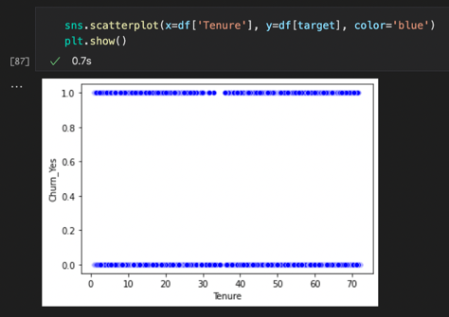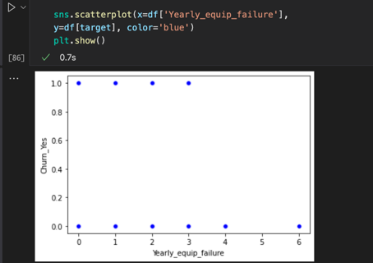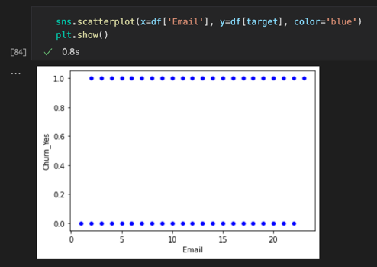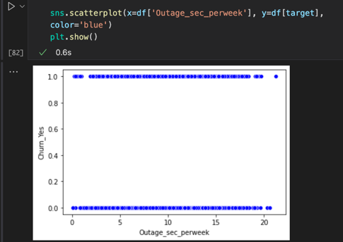

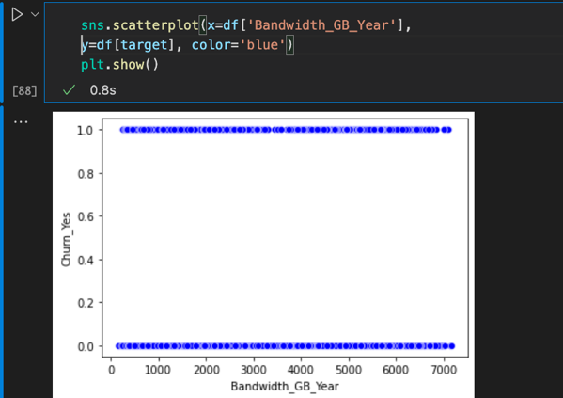

Now we can create a heatmap to look at the variables from a holistic view.

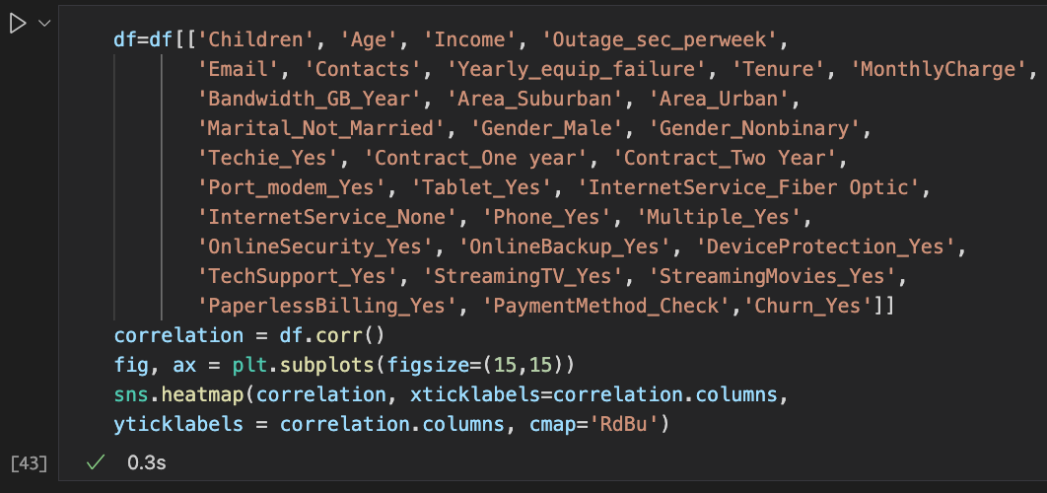

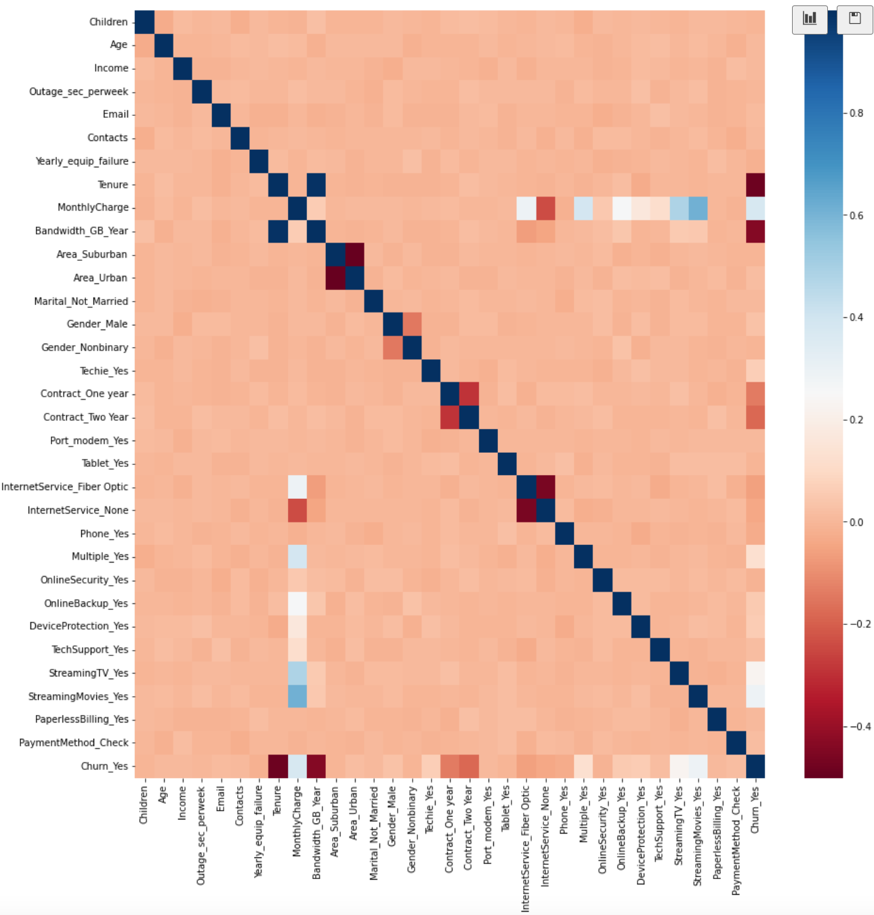

The previous analysis shows a relationship between customer churn and a few of the predictor variables. We can look at the correlations of the following to see if we want to use them in the upcoming logistic regression analysis: Children, Age, Income, Contacts, Yearly_equip_failure, Bandwidth_GB_Year, Gender_Male, Port_modem_Yes, StreamingTV_Yes, StreamingMovies_Yes, PaperlessBilling_Yes, and PaymentMethod_Check.

1. Provide a copy of the prepared data set.

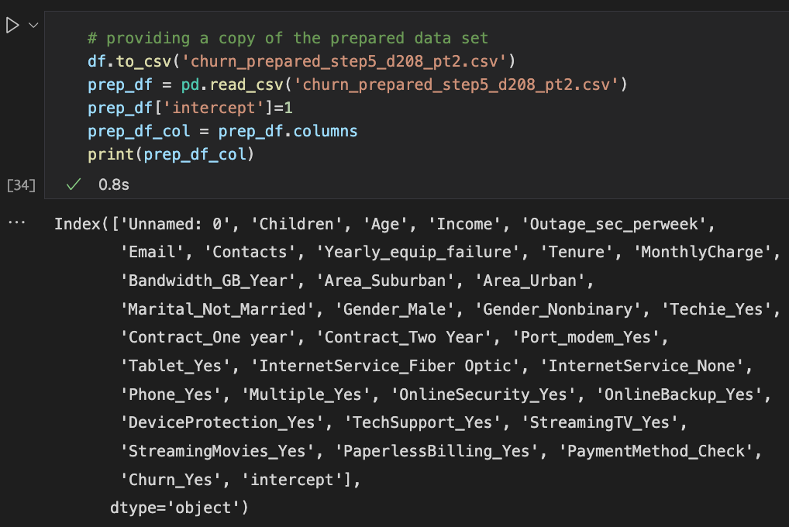

**Part IV: Model Comparison and Analysis**

D: Compare an initial and a reduced logistic regression model by doing the following:

1. Construct an initial logistic regression model from *all* predictor variables that were identified in part C2.

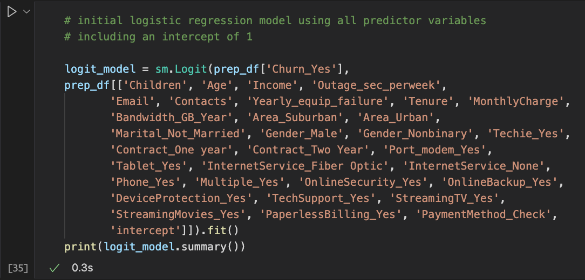

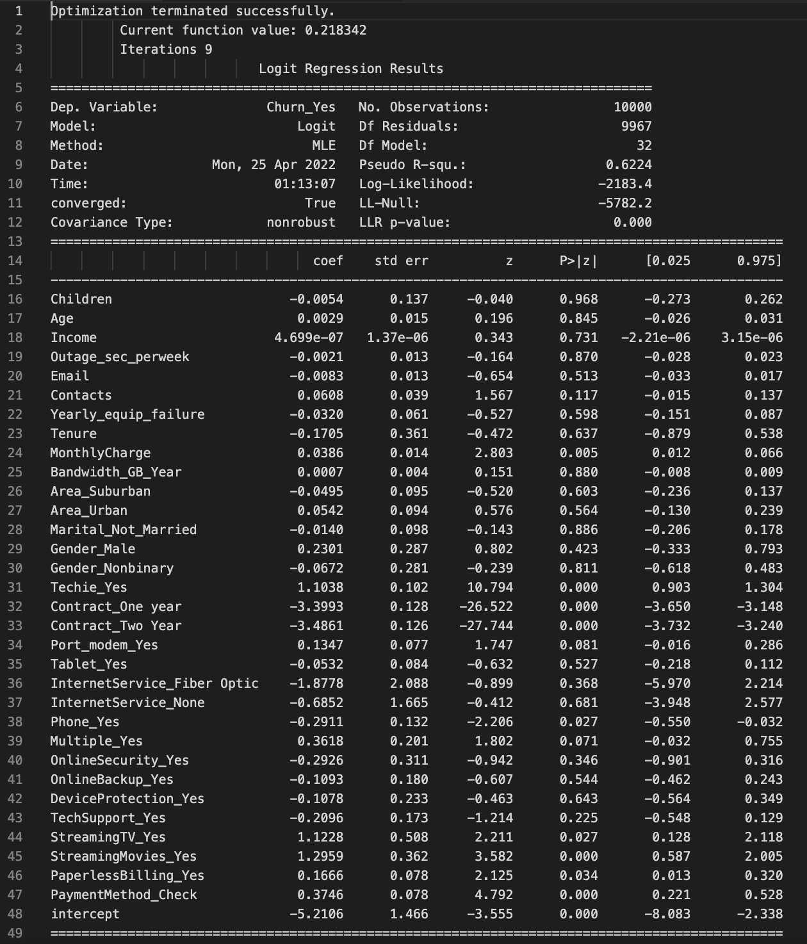

Here are the details of the Logit Regression Results:

There are 32 total predictor variables among which 22 are categorical variables and 10 are numerical variables. The Pseudo R value is 0.6224.

1. Justify a statistically based variable selection procedure and a model evaluation metric to reduce the initial model in a way that aligns with the research question.

We can look at the logit models for only the numerical variables vs only the categorical variables and compare those to the logit model with all the variables.

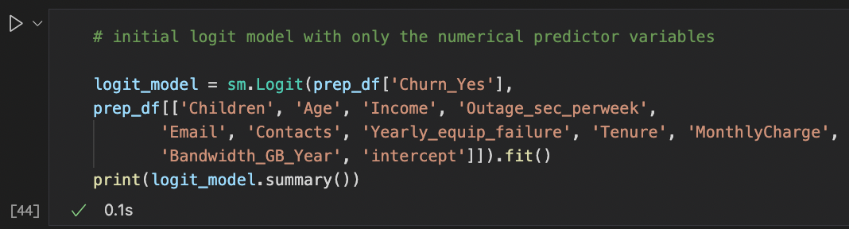

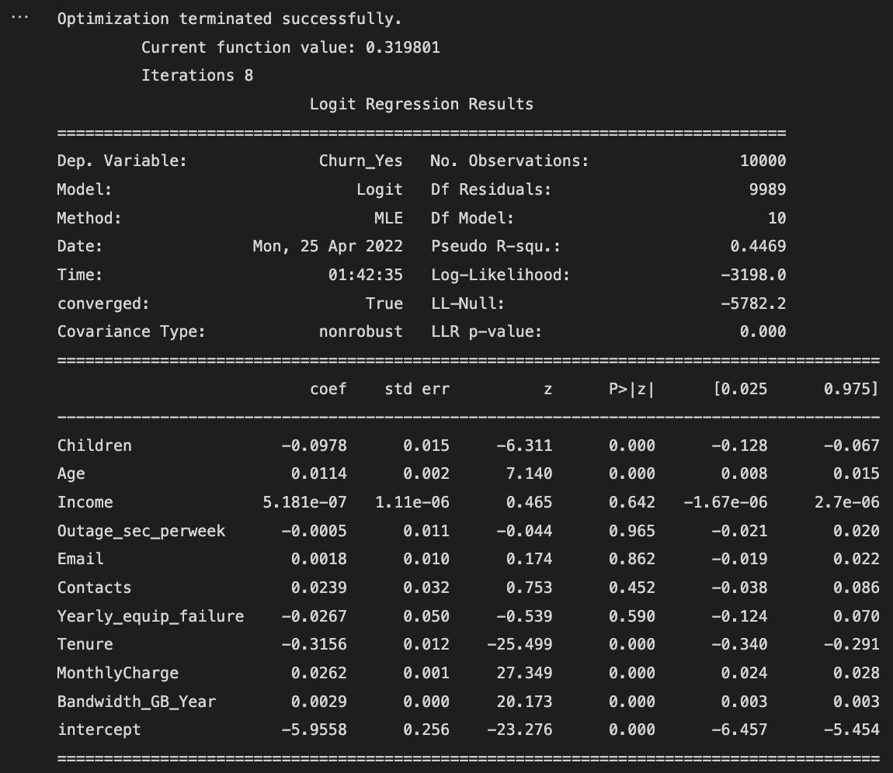

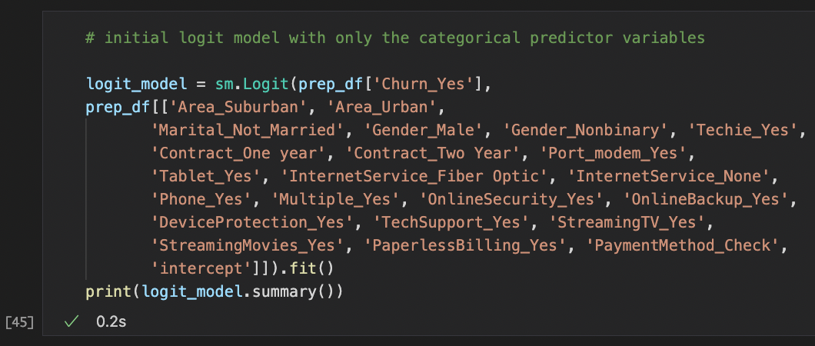

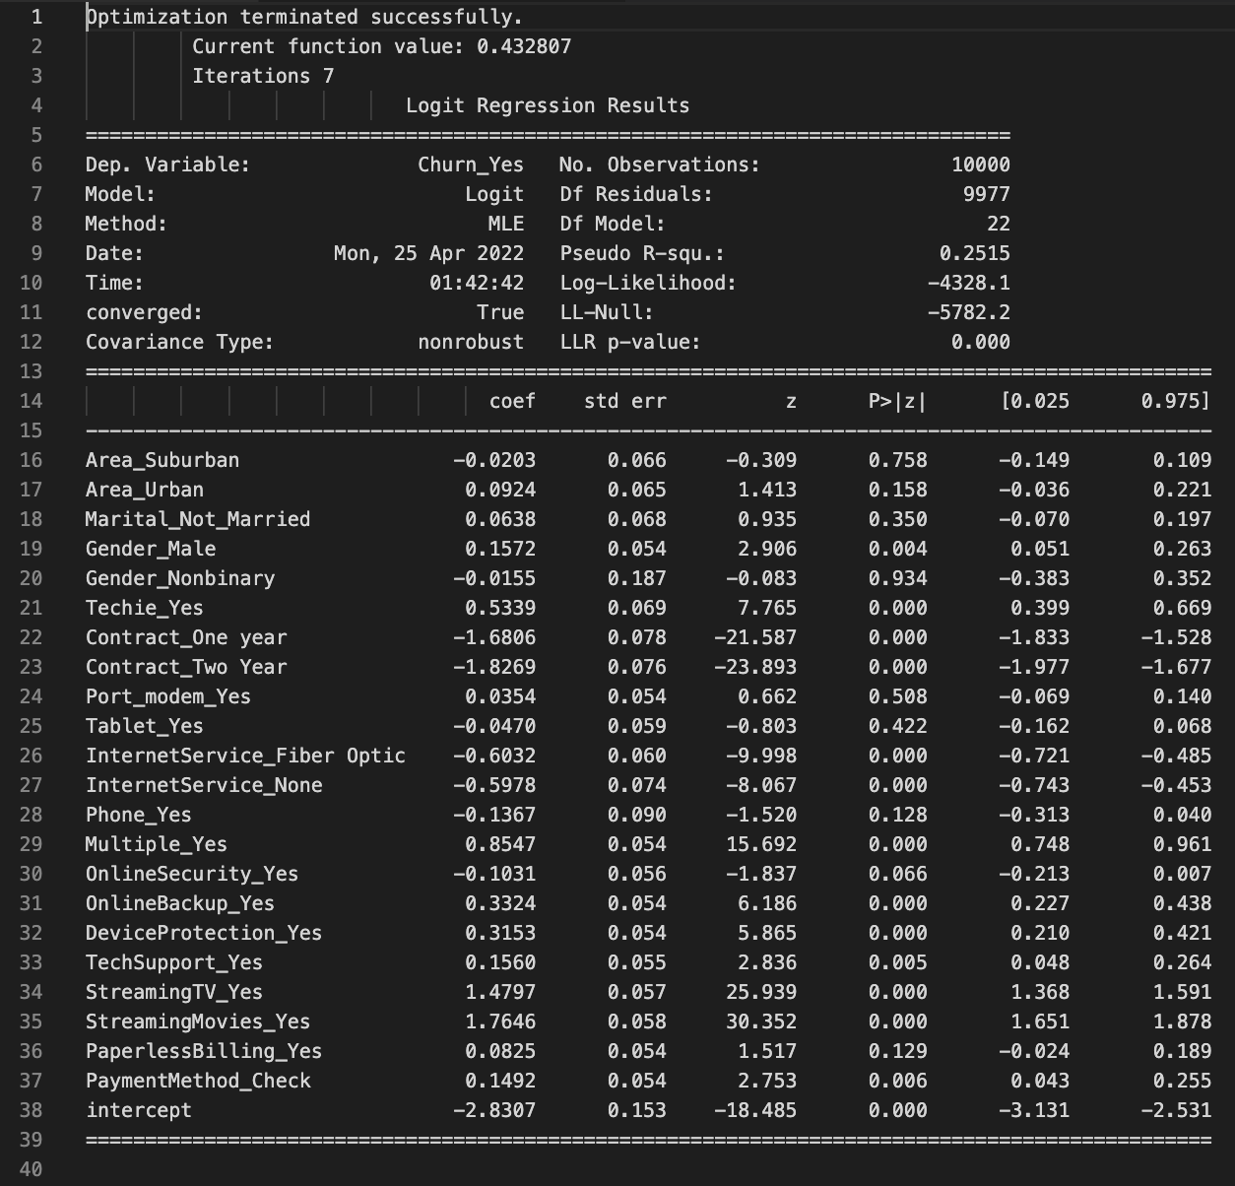

We can see that the Pseudo R value for the numerical-only logit model is 0.4469 and for the categorical-only logit model it is 0.2515. This means that a good fit will probably include a combination of numerical and categorical variables. The initial model has a total of 32 variables and the Pseudo R for that is 0.6224, as mentioned above.

We will look at the coefficients and the p-value as a determinant to highlight some of the variables. Our p-value will be 0.05 and any variables that have a higher p-value may not be statistically significant.

The second valuation method that we can use to reduce the variables is to look for multicollinearity between variables.

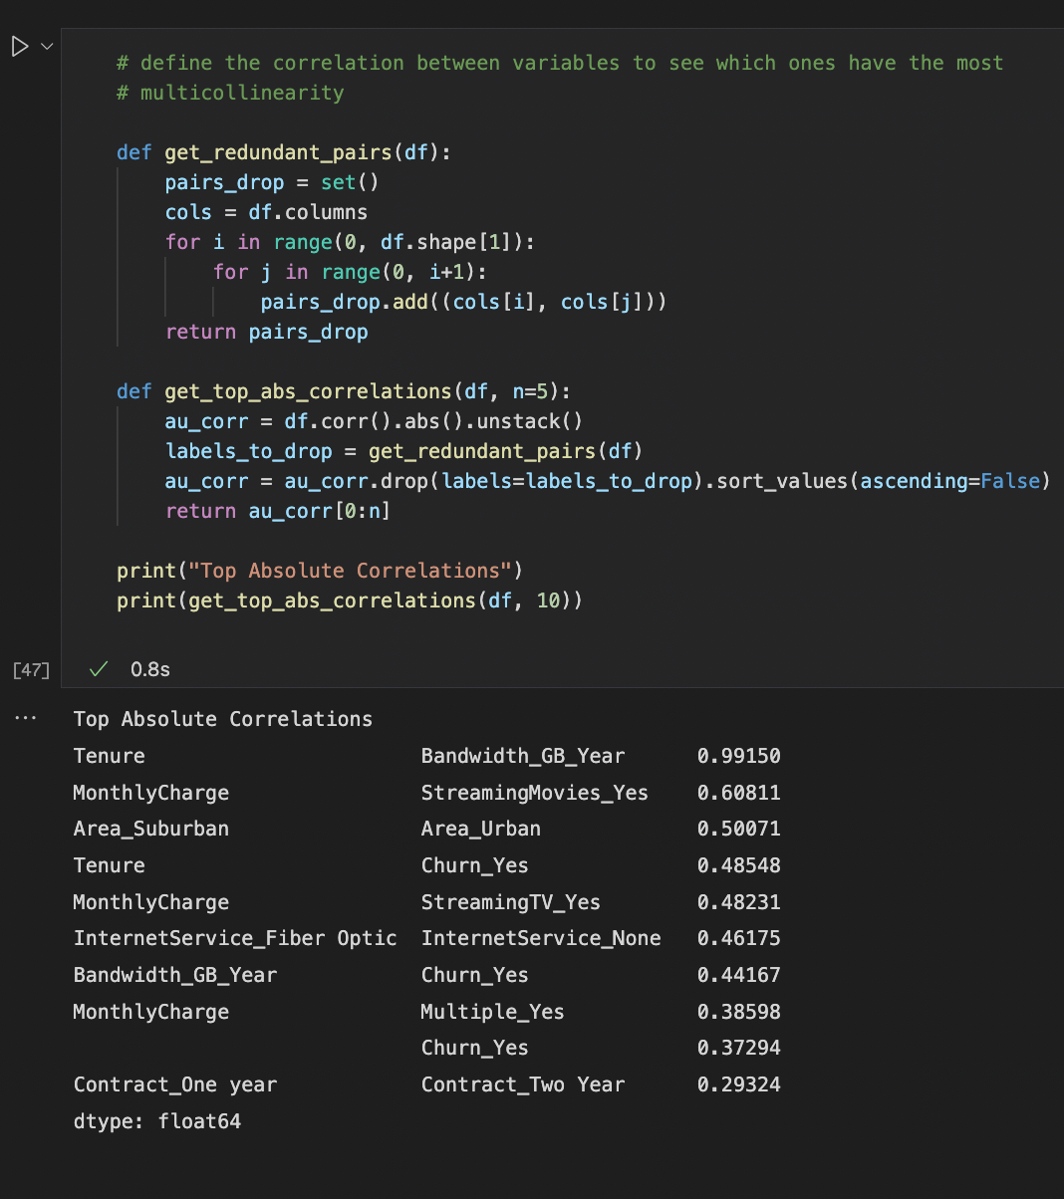

This shows that there is a correlation between a few of the variables like Tenure and Bandwidth_GB_Year which makes sense, however we can probably get rid of a few of these variables that are causing multicollinearity.

Because we are trying to figure out which customers are at risk of churning and predicting which variables may affect this, we keep in mind the business question and that some of the predictor variables may not be significant in predicting that.

The next iteration for the logit model will include the following predictor variables:

1. Tenure (continuous)
2. MonthlyCharge (continuous)
3. Techie_Yes (categorical)
4. Contract_One year (categorical)
5. Contract_Two year (categorical)
6. InternetService_Fiber Optic (categorical)
7. Multiple_Yes (categorical)
8. OnlineSecurity_Yes (categorical)
9. OnlineBackup_Yes (categorical)
10. DeviceProtection_Yes (categorical)
11. TechSupport_Yes (categorical)
12. StreamingTV_Yes (categorical)
13. StreamingMovies_Yes (categorical)
14. PaperlessBilling_Yes (categorical)

That’s 14 variables where 2 are continuous and 12 are categorical.

1. Provide a reduced logistic regression model. (Note: The output should include a screenshot of each model.)

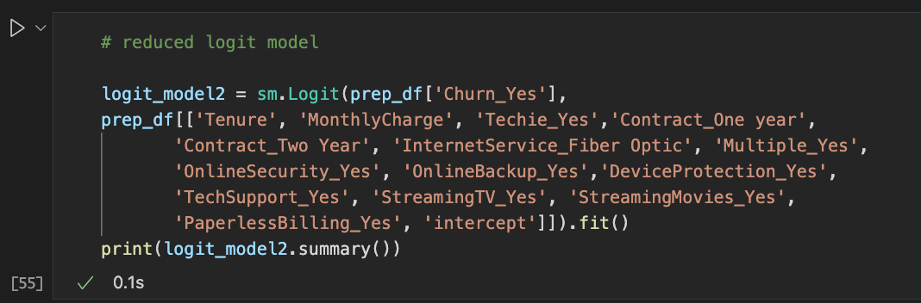

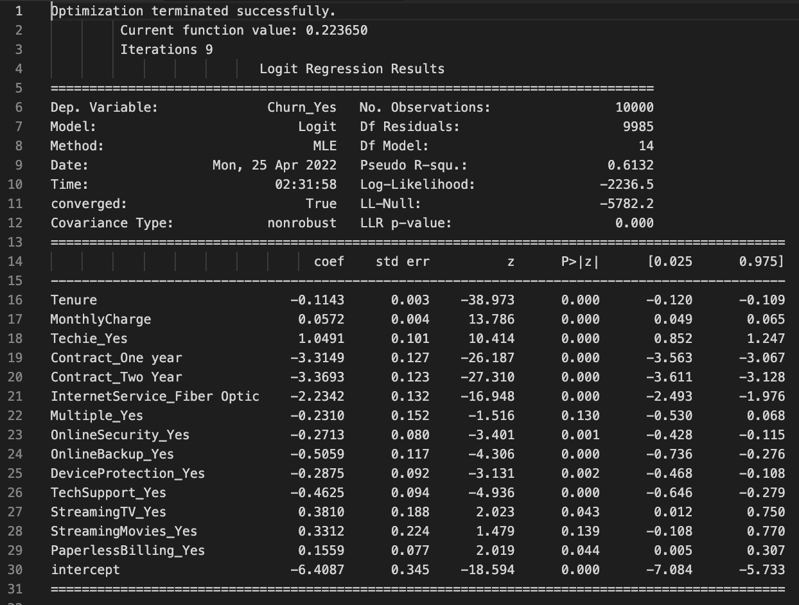

This logit model shows a Pseudo R value of 0.6132. We reduced the variable count from 32 to 14. The original logistic regression analysis showed a Pseudo R value of 0.6224. That means that these variables may be a great fit for the model. Even though the original model didn’t have a high Pseudo R value, we see that we have a very close fit with our reduction model of 14 variables.

E: Analyze the data set using your reduced logistic regression model by doing the following:

1. Explain your data analysis process by comparing the initial and reduced logistic regression models, including the following elements:
   * The logic of the variable selection technique
   * The model evaluation metric

The initial logistic regression model had a pseudo-R that explained 62.24% of variance. Our logistic regression model with the reduced variables explains 61.32% of variance by the pseudo-R. We used p-values of 0.05 to predict statistical significance of variables and used a correlation analysis to find multicollinearity between variables.

We can see a model evaluation metric through a heatmap and a confusion matrix.

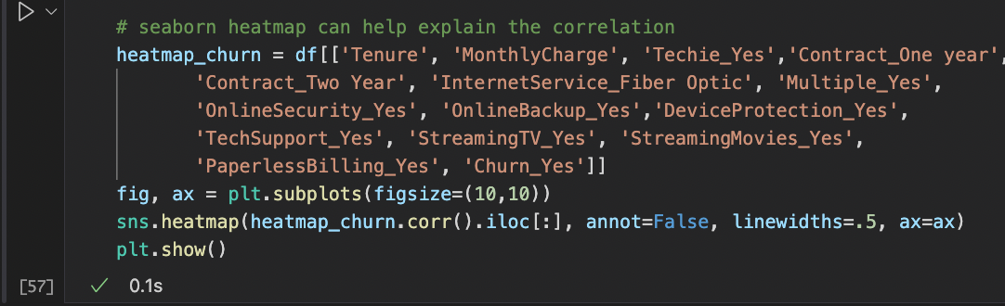

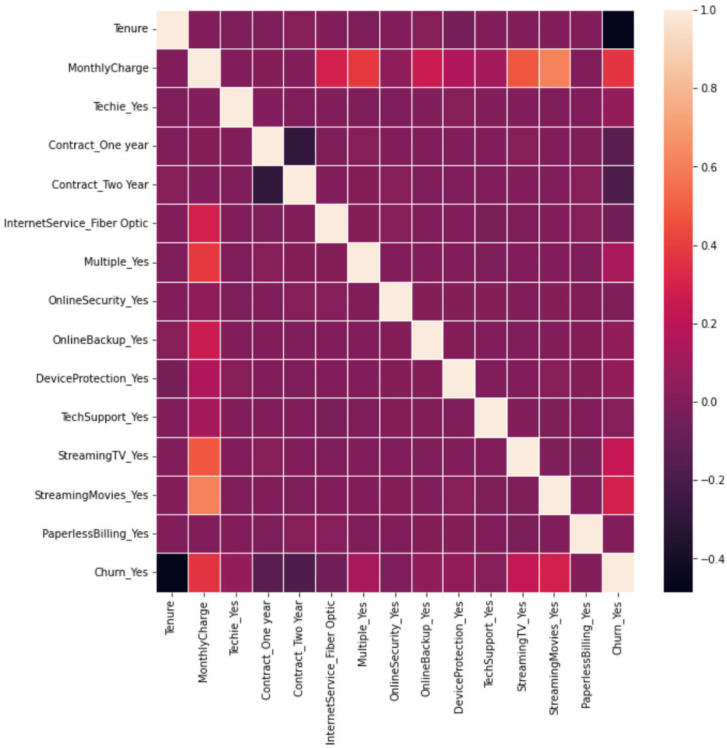

Now we can create a confusion matrix using sklearn.

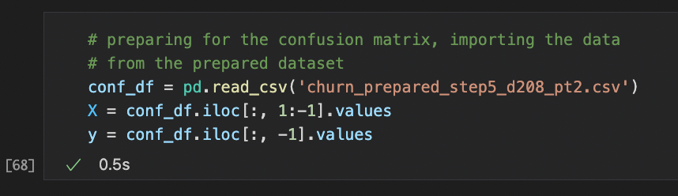

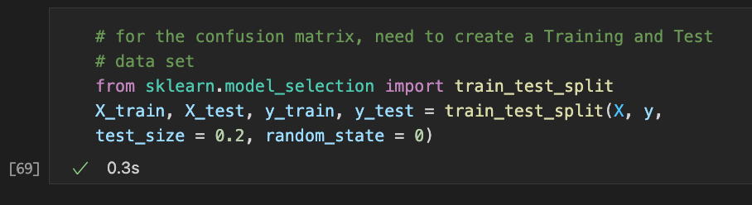

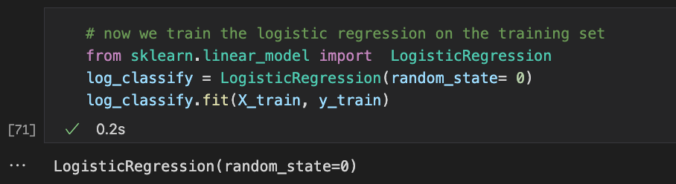

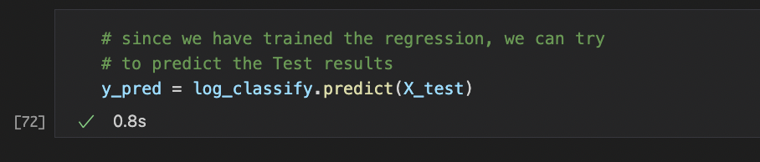

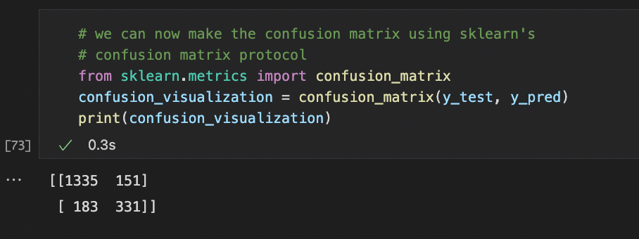

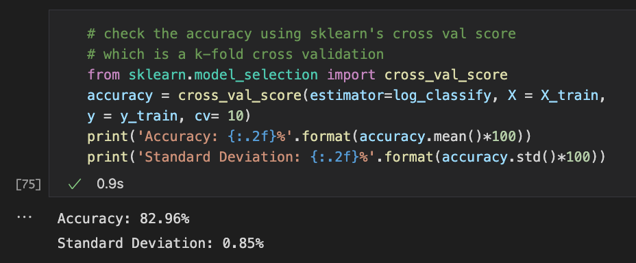

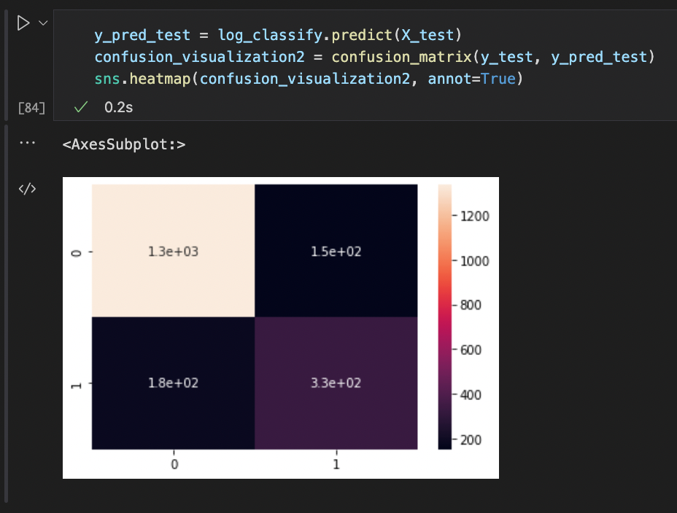

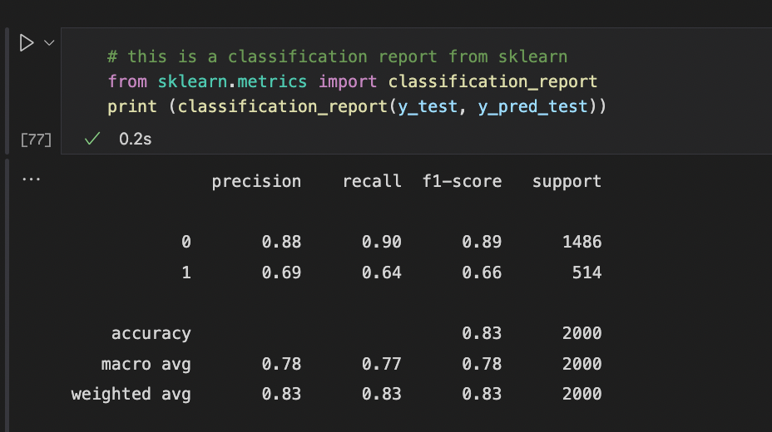

1. Provide the output and *any* calculations of the analysis you performed, including a confusion matrix. (Note: The output should include the predictions from the refined model you used to perform the analysis.)

All output and calculations screenshotted above.

1. Provide the code used to support the implementation of the logistic regression models.

All code screenshotted above.

**Part V: Data Summary and Implications**

F: Summarize your findings and assumptions by doing the following:

1. Discuss the results of your data analysis, including the following elements:
   * A regression equation for the reduced model
   * An interpretation of coefficients of the statistically significant variables of the model
   * The statistical and practical significance of the model
   * The limitations of the data analysis

The logistic model has been regressed and is complete as far as being a proper fit. There is a variation of variables of 2 numerical and 12 categorical.

The regression equation for the final model is:

$$y=-6.41 \left(const\right)-0.11 x \left(Tenure\right)+0.06x \left(MonthlyCharge\right)+1.05 x \left(TechieYes\right)-3.31 x \left(ContractOneYear\right)-3.37 x \left(ContractTwoYear\right)-2.23 x \left(InternetServiceFiberOptic\right)-0.23 x \left(MultipleYes\right)-0.27 x \left(OnlineSecurityYes\right)-0.51 x \left(OnlineBackupYes\right)-0.29 x \left(DeviceProtectionYes\right)-0.46 x \left(TechSupportYes\right)+0.38 x \left(StreamingTVYes\right)+0.33 x \left(StreamingMoviesYes\right)+0.16 x (PaperlessBillingYes)$$

This model has a total of 14 predictor variables, the pseudo-R value is 0.6132 which means that 61.32% of the variance can be explained by this model. This indicates a decent model and fit for explaining variability.

We also notice most of the variables have negative coefficients. At first glance, I was confused at understanding why but when put into business terms it makes sense. Most of the services and being on a one year or two-year contract have very negative coefficients which means that customers who are subscribed to these features and long-term contracts are **less** likes to churn. This is because our target variable was Churn_Yes, meaning we were looking for customer churn which means customers who are at risk of terminating their service.

The equation may be able to accurately predict the risk of a customer churning depending on the different services that the customer has purchased and the contract type that the customer is on.

Limitations of the data are that the dataset could have a larger sample size. Another limitation of the data analysis would be that bias against certain features or contract types. For instance, if a customer were to select to be on the month-to-month contract, the company may have a bias that these types of customers are unreliable since they are more likely to churn.

1. Recommend a course of action based on your results.

The recommendation to this business would be to use this regression equation to predict the risk of customers churning. The recommendation to the business is to upsell customers on features that the company is offering like multiple lines, online security, online backup, device protection, and tech support. These features can incrementally decrease the risk of a customer churning if put together. To really prevent a customer from churning, enroll the customer in a year or two-year contract instead of month-to-month. Also, ensure that the customer purchases fiber optic internet service. It seems like this reduces the risk of customer churn by 2-fold.

**Part VI: Demonstration**

G: Provide a Panopto video recording that includes *all* of the following elements:

* a demonstration of the functionality of the code used for the analysis
* an identification of the version of the programming environment
* a comparison of the **two** logistic regression models you used in your analysis
* an interpretation of the coefficients

(Note: The audiovisual recording should feature you visibly presenting the material (i.e., not in voiceover or embedded video) and should simultaneously capture both you and your multimedia presentation.)

<https://wgu.hosted.panopto.com/Panopto/Pages/Viewer.aspx?id=df9a2cc5-86a5-47af-aa61-ae82008b2b9b>

H: List the web sources used to acquire data or segments of third-part code to support the application. Ensure the web sources are reliable.

[Regression Analysis with Python](https://realpython.com/linear-regression-in-python/)

I: Acknowledge sources, using in-text citations and references, for content that is quoted paraphrased, or summarized.

n/a

J: Demonstrate professional communication in the content and presentation of your submission.

n/a